How to convert Darknet yolov2/3 model to bmodel and inference in darknet framework

We have provided darknet inference demo for yolov2/3 bmodel(<https://github.com/BM1880-BIRD/bm1880-ai-demo-program/tree/master/darknet-yolov2-object-classification-v2>). For fast model customization, please follow below steps to convert Darknet yolov2/3 model to bmdel(which run in bm1880 platform).

1. How to convert Darknet model（cfg and weights）to bmodel.
2. Please refer to below open source tools to convert.

<https://github.com/ChenYingpeng/caffe-yolov3>

<https://github.com/marvis/pytorch-caffe-darknet-convert>

caffe-yolov3/yolov3_darknet2caffe.py in first tool to convert yolov3 model to caffe model.darknet2caffe.py in second tool to convert yolov2 model to caffe model.

Pytorch and caffe should be installed first to run these two python script. I used below pip method to install Pytorch(<https://pytorch.org/>). Caffe installation will not guild hear. (upsample and reorg layer support should be added in caffe).

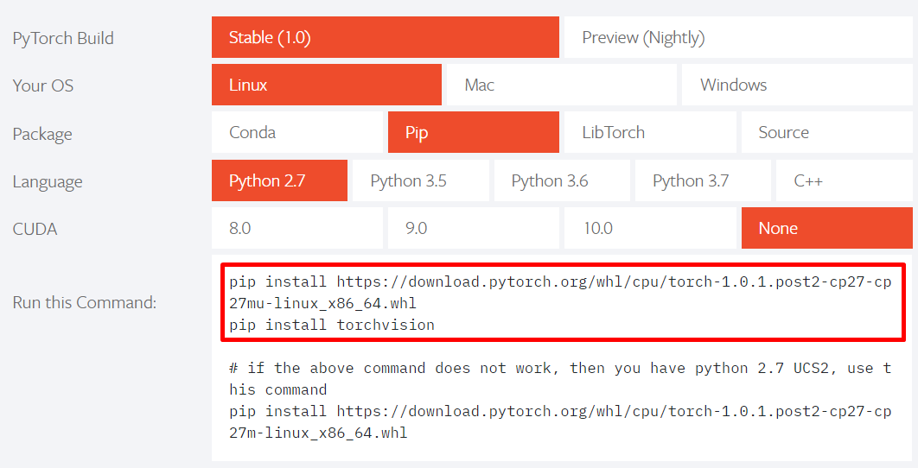

Origin darknet2caffe.py only support tiny yolo model convert(no reorg and mulita parameter route layer support ). Please add below patch to support yolo model convert.



I move caffe-yolov3/yolov3_darknet2caffe.py to pytorch-caffe-darknet-convert folder to reduce env setting up.

Please use below cmd for yolov3and yolov2 model convert. Then caffe prototxt and caffemodel will be generated.

python yolov3_darknet2caffe.py yolov3.cfg yolov3.weights　yolov3.prototxt yolov3.caffemodel

python darknet2caffe.py yolov2.cfg yolov2.weights yolov2.prototxt yolov2.caffemodel

**You don’t need to write caffe prototxt only darknet cfg and weights are needed, which is convenient point .**

For caffemodel ，you only need to save to conv layer as last layer, please refer to below result.



Then you can use calibration tool to do quantization and convert to bmodel , please refer to below resnet example.

<https://sophon-edge.gitbook.io/project/toolkit/bmnet-compiler>

**Please pay attention to prototxt input layer during qutization，I used original yolo model ，normalization (0.00392156862 = 1/255) should be included. All in all , you should keep the same preprocess as model training. (e.g. reduce means or normalization ).**

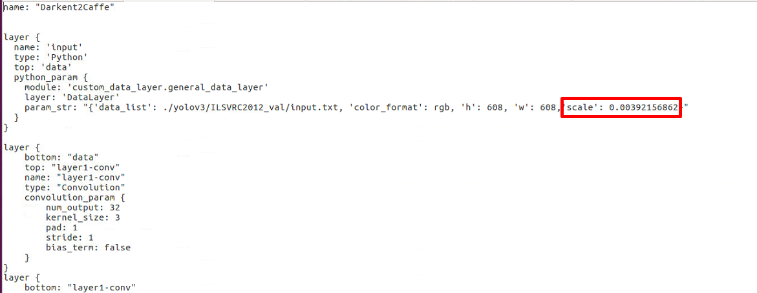

===========================================================

===========================================================

另外，如果有自己实现caffe model (prototxt), 可以用如下的python script 完成caffe model的生成。

执行方式：将yolov2.prototxt 和yolov2.weights放到相同的目录。

执行：　python convert_weights_to_caffemodel_yolo2.py



1. Using bmodel to inference in darknet framework
2. Put your own bmodel(follow above steps) to below folder

<https://github.com/BM1880-BIRD/bm1880-ai-demo-program/tree/master/darknet-yolov2-object-classification-v2/darknet/models/bmnet>

1. Modify cfg file in darknet
2. Yolov2

Below red part need to change for your own customization model.

darknet/cfg/bmnet_yolov2.cfg

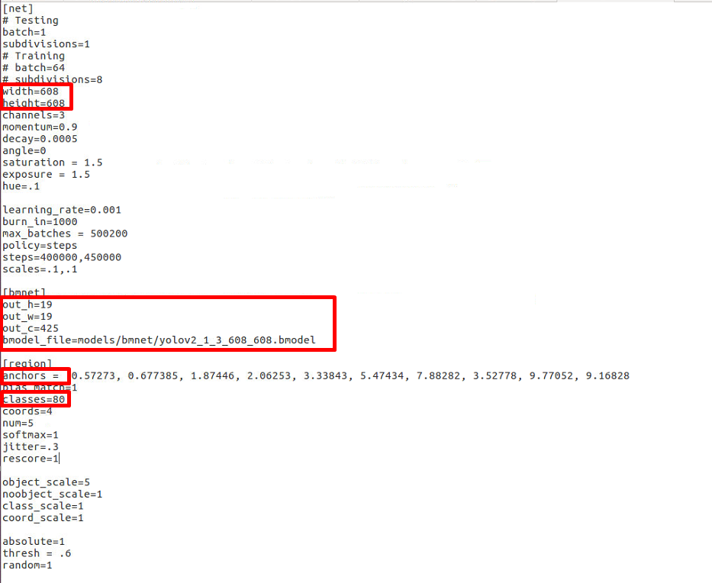

out_c = out_c=5*(4+1+classes), classes is object type number。

Anchors value shold be same as darknet training.

1. Yolov3

darknet/cfg/bmnet_yolov3.cfg

Below red part need to change for your own customization model.

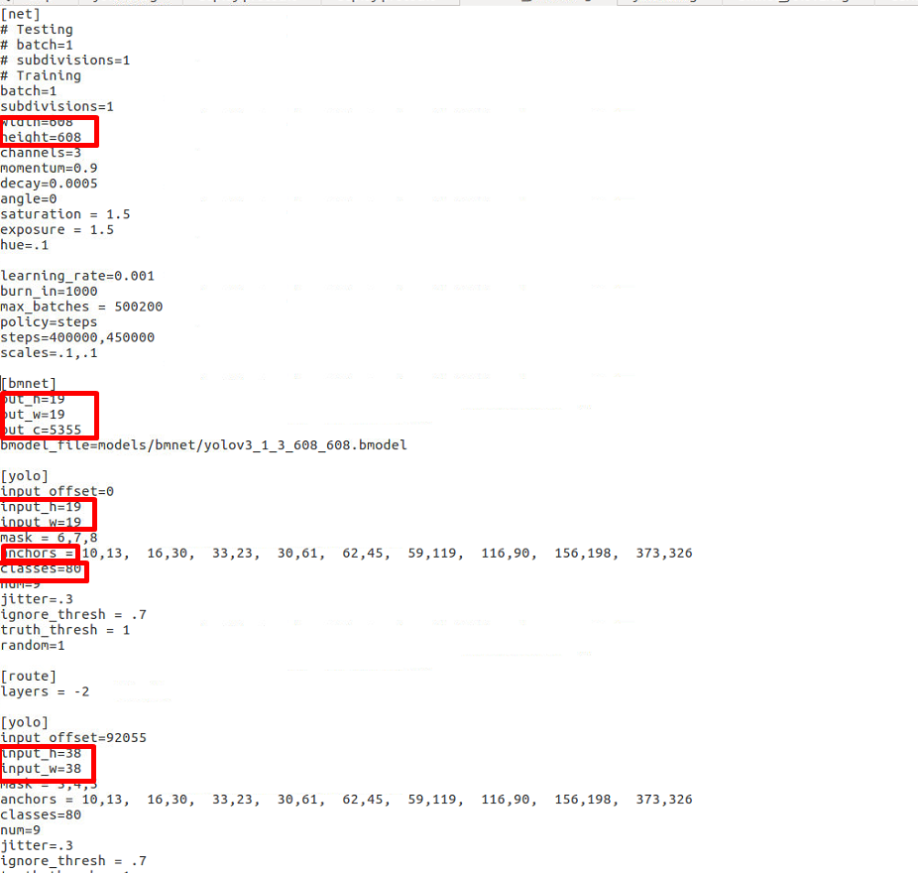

In original 608 model out_c = 19*19*255+38*38*255+76*76*255 /19*19，in which 255=３*(4+1+80)，80 is object type number. Bmnet model output = 19(out_h)X19(out_w)X5355(out_c)

Red part should be set as your own customization model.